1. 
2. **Agenda**:
   1. Kafka related terminologies and where to find more information about it.
3. Let’s first understand the flow of how Kafka Consumer in general is going to read the records from the Kafka Topic.
4.   
   Kafka Consumer can consume records/msgs from multiple topics but not recommended.
5. What are the options available to configure Kafka Consumer.
6. 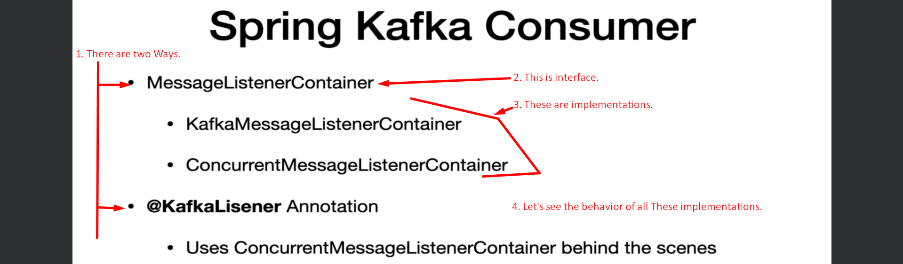
7. **KafkaMessageListenerContainer**.  
   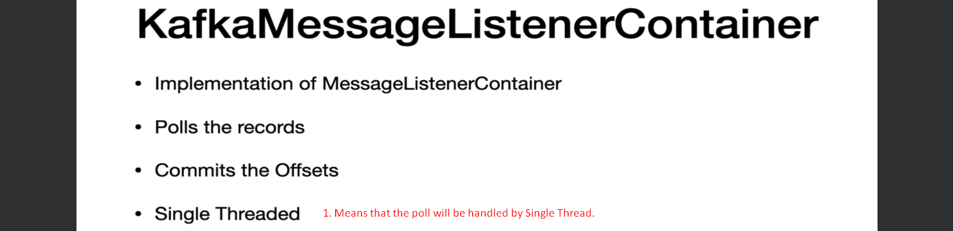
8. **ConcurrentMessageListenerContainer**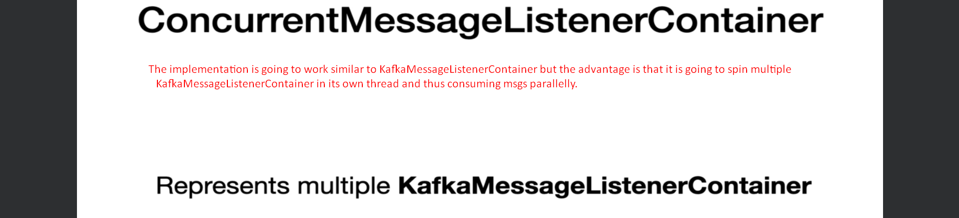
9. In the following slide, “bean method” means that the @KafkaListener must be put on some method which is inside a Spring Bean. 😊  
   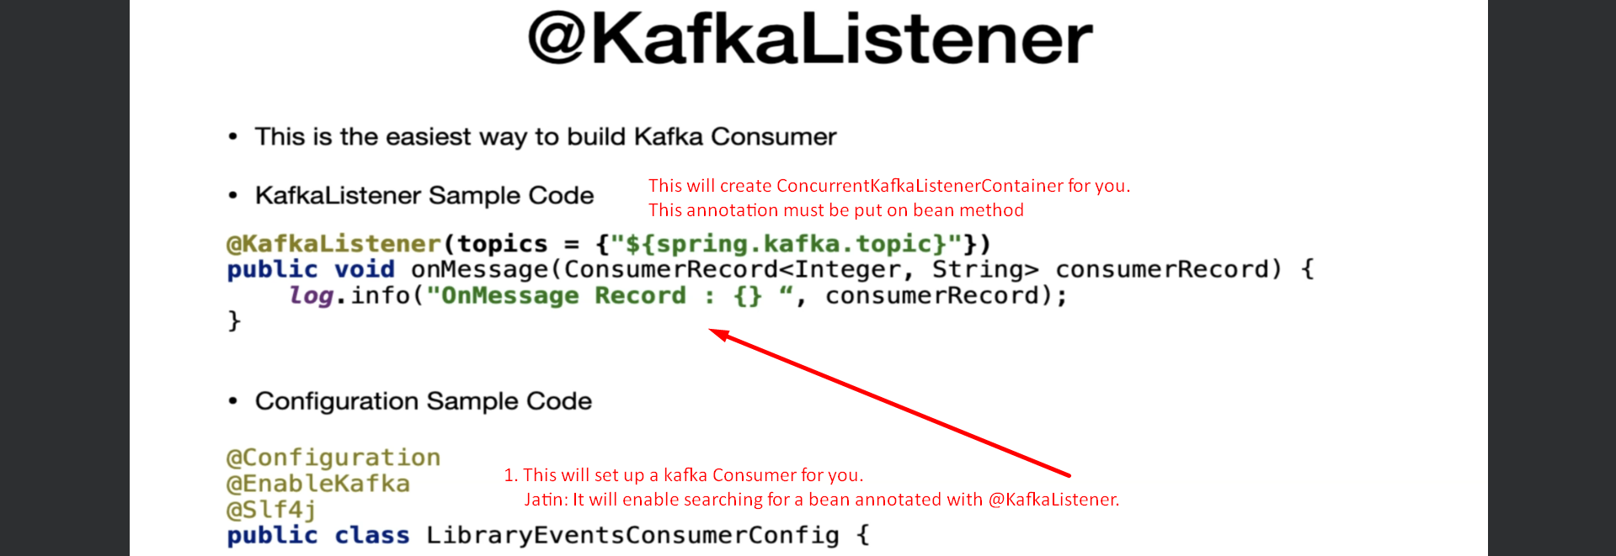
10. **Consumer Configuration**:   
    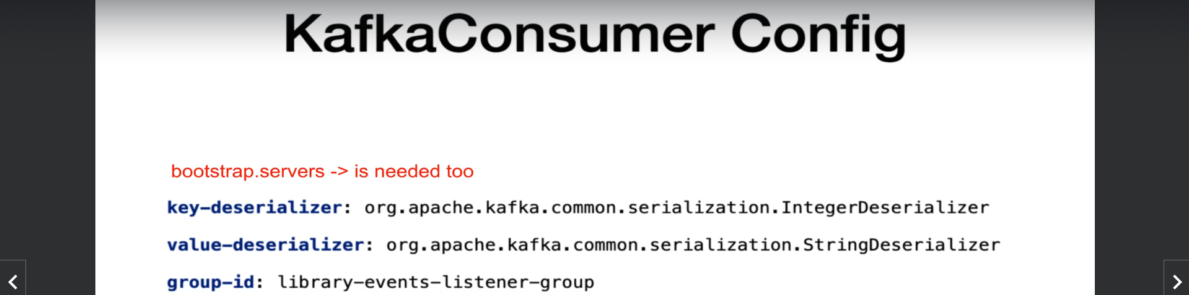
11. **Let us see where we can find more info about Kafka Consumer.  
    All the above discussed info can be found on this page.**